**St. Francis Institute of Technology Borivli (West), Mumbai-400103**

**(Autonomous Institute)**

**Department of Information Technology**

**Sub: Internet Programming**

**Experiment -5: Design of React App**

**1. Aim:** To setup a development environment to build a react app and test it using “Hello world” program.

**2. Objective:** After performing the experiment, the students will be able to understand and design front end applications using react.

**3. Lab Outcome:** Students will be able to construct front end applications using React (PO3, PO5, PSO3, PSO4)

**4. Prerequisite:** HTML, CSS, node.js, react

**5. Requirements:** The following are the requirements **–**

• PC/Laptop

• Visual Studio Code

• Browser

**6. Pre-Experiment Theory:**

React is a declarative, efficient, and flexible JavaScript library for building user interfaces. It is used to build single-page applications. It lets you compose complex UIs from small and isolated pieces of code called “components”.

React creates a VIRTUAL DOM in memory. Instead of manipulating the browser's DOM directly, React creates a virtual DOM in memory, where it does all the necessary manipulating, before making the changes in the browser DOM. React finds out what changes have been made, and changes only what needs to be changed.

To learn and test React, you should set up a React Environment on your computer. The create react-app tool is an officially supported way to create React applications. Node.js is required to use create-react-app.

**7. Laboratory Exercise:**

**A. Procedure**

• Add following extensions in vs code (Recommended) – Babel JavaScript, JavaScript ES6 Code Snippets, vs code icons

• Install node.js (npm installs automatically)

• Open terminal window (use cmd command)

• Check version of node.js (node -v)

• Check version of npm (npm -v)

• Install react from terminal using following commands -

• npm install -g create-react-app

**1 |Internet Programming Lab**

• create-react-app –version

• d:

• mkdir <foldername>

• cd <foldername>

• create-react-app <projname> (may take a few minutes)

• cd <projname>

• npm start (localhost:3000 – react app installed in local system)

• Open vs-code and open the folder.

• Write your code for hello world in vs code

To view the output, reload the react app or again type *npm start* in command window Check output

**B. Program Code**

• Setup the development environment to build a React app using the steps given in Procedure.

• Test it using the “Hello world” program by making appropriate changes in the default environment created.

**8. Post Experimental Exercise**

Q 1. Explain the use of setState() method change the state of the React.js component with an example?

Q 2. Differentiate between states and props.

**9. Results/Observations/Program output:**

Present the command window screenshots, program codes and output

**10. Conclusion:**

Write what was performed in the experiment

Write which all features of React you used to perform the experiment

**11. References:**

• https://nodejs.org/en/

• https://www.thapatechnical.com/2020/05/install-reactjs-windows-install-nodejs.html • https://www.kirupa.com/react/setting_up_react_environment.htm

• <https://youtu.be/tg73NsiQOUE>

**2 |Internet Programming Lab**

• Setup the development environment to build a React app using the steps given in Procedure.

**Commands:**

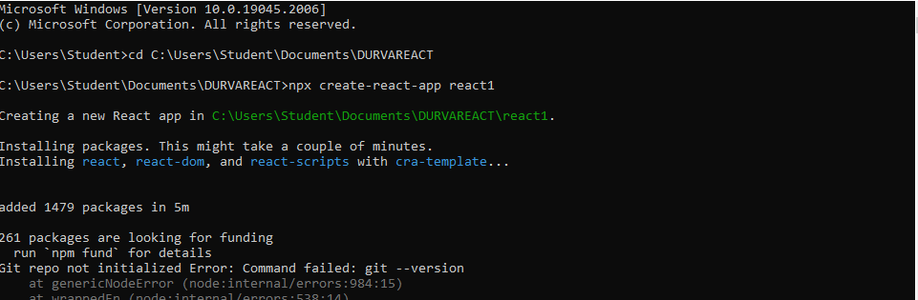

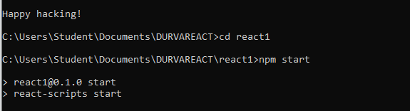

**App.js:**

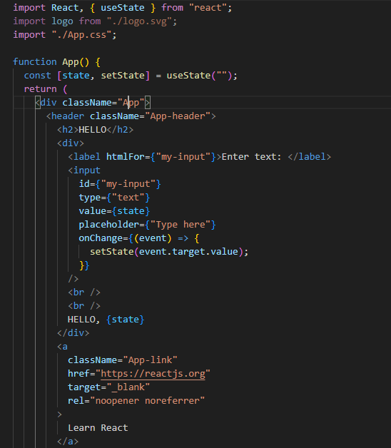

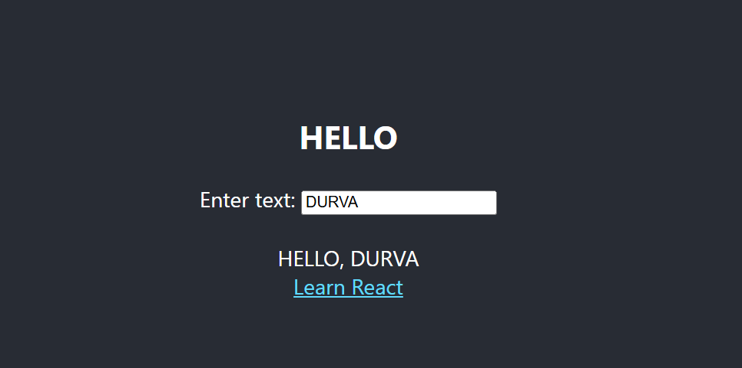

**VEHICLE COMPONENT. FUNCTIONAL:**

function Vehicle() {

return <h1> I I am a bike</h1>;

}

export default Vehicle;

**CLASS:**

import React from "react";

class Vehicle1 extends React.Component {

render() {

return <h1>I I am a coconut</h1>;

}

}

export default Vehicle1;

